District 36 Business Meeting Minutes
Tuesday, August 1st, 2023

- Serenity Prayer
- Twelve Traditions; Jenny
- Eighth Concept for World Service; Paul C.
- Welcome
- Roll call; Paul C., Mike L., Tami B., Patrick, Natalie, Glenda R., Kent C., Edd, Virgil O., Linda Z., Jenny, Danny, Brian, Robert L., Mike and Ted.
- August Anniversaries. Brian is celebrating 8 years.
- Introduction of any new General Services Representatives (GSRs) in attendance, No new GSR’s present.
- GSR Reports
Glenda GSR from Thursday night in Carnation at 7:30 P.M. at the stone church we have a circle in the middle, it’s a great meeting with a lot of sobriety. We’re doing good, it’s gotten bigger!
Patrick the Alt. GSR from the Friday night Candlelight in Duvall, we are in person and online. You can Zoom in or come and see us in the basement of the Holy Innocents Church at 8:00 P.M.

- Committee Chair Reports
  - Accessibility - OPEN
  - Archives - OPEN
  - Bridge the Gap/Treatment - Josh L., Not Present.
  - Corrections - Natalie C., Not a lot of movement. I have found the literature that came out of corrections. I’m making a trip to Echo Glenn next week to see if they want to distribute that literature at the facility. I haven’t had a great email response from there so I’ll hoping to meet someone one on one.
  - Cooperation with the Professional Community / Public Information (CPC/PI) - David B., emailed Paul his report. He has made copies of the new schedule and has been distributing them in North Bend. This month I am planning to go with Vinnie to Snoqualmie, Fall City and Duvall to put them in more public places.
  - Eastside Intergroup Representative - Kent C., Nothing to report currently. Check out eastsideaa.org for the Picnic and Poker run info. Tickets are available online and at the eastside intergroup office.
  - Events - Dale D., Not Present.
  - Grapevine/Literature - Linda Z., I just got the keys from Kewn for the cabinet at hope Hall. I have literature in my car, I’ve taken a picture of all the inventory so I can see what we have and what we’re missing. I was wondering if there was a budget, (the Treasurer informed that there is a budget of $300). and how I order what I need. I’m planning to go to the birthday meetings around the district, the big one I know of is the Birthday meeting in Snoqualmie on the last Friday of the month, I set up a nice display with a tablecloth with the books and literature I had. It’s a great opportunity for anyone that wants to buy a book, they won’t have to visit the GSO Office. Eventually people will get to know that they can also get them at the birthday meeting. If people would please let me know when your home group celebrates Birthday night I would be happy to come and set up a display. I have a key to Hope Hall and the closet inside where the literature is stored.
  - Third Legacy - OPEN
  - Web and Digital - Virgil O., I figured out that posts that won’t expire is caused by checking the box that says, send to the top of page, so when you build a post please make sure that box is not checked or it won’t expire like it supposed to. Another thing is, although everyone is doing a good job posting please do not mess with the forwarder. I have made some corrections and I would rather people send me those things and I will make the changes because it’s kind of a sensitive issue. The web page is doing well and everybody is doing good with the posts. If you haven’t been on in a while log on and check it out.
  - Young People in A.A. - OPEN
- Pause for the Seventh Tradition
  - “Every A.A. group ought to be fully self-supporting, declining outside contributions.”
  - District 36 PayPal link put in the chat.
- Officer Reports
  - Registrar - Tami B., I have made a spread sheet of all the meetings on the online schedule and the written schedule and made a comparison for all the meetings we have GSR contacts for. I did a complete audit of that.
  - Treasurer - Glenda R.,
Motions were made and seconded, Budgets for June and July Passed unanimously without opposition.
  - Secretary - Edd A.
  - Motion was made and seconded, Secretary report was Passed.

Alternate District Committee Member (Alt DCM) – Mike L.

Electronic meeting equipment:
- Purchase the speakerphone for district use. We now have the speakerphone and USB camera for permanent district use.
- Complete list of items needed to run the hybrid meeting.
No. | Item | Source | Use | Cost
1 | Projector | Loan from church | Video display | 0
2 | Laptop | Loan from member | Zoom host | 0
3 | Camera | District | Meeting video | 0
4 | Speakerphone | District | Meeting audio | 0
5 | Tripod | Purchase | USB camera stand | 40
6 | 20' USB extender | Purchase | Long extension cable PC to Camera | 26
7 | 15' HDMI | Purchase | Long video cable for projector | 12
8 | 15' ext cord | Purchase | Power for computers at conf table | 17
9 | 10' ext cord | Purchase | Power for projector | 8
10 | Power strip | District | Power for computers at conf table | 0
11 | Case | District | Storage box | 0

- Outstanding purchase items still need approval and will be approximately $103.00.

Completed registration and hotel reservation for October assembly.
Published one update to the district meeting schedule. Work with Registrar (Tami) via e-mail on updates to schedule and complete list of meetings for district use
Talked with Ray H about gratitude dinner information. He provided a bunch of e-mails with work items from previous dinners.
TODO: send out district guidelines to groups and committee for feedback and update ideas. I will complete this through e-mail and get suggested updates back to business meeting for approval.

District Committee Member (DCM) – Paul

Open District Roles
The following table shows the service roles we have open and my subjective priority for getting them filled.
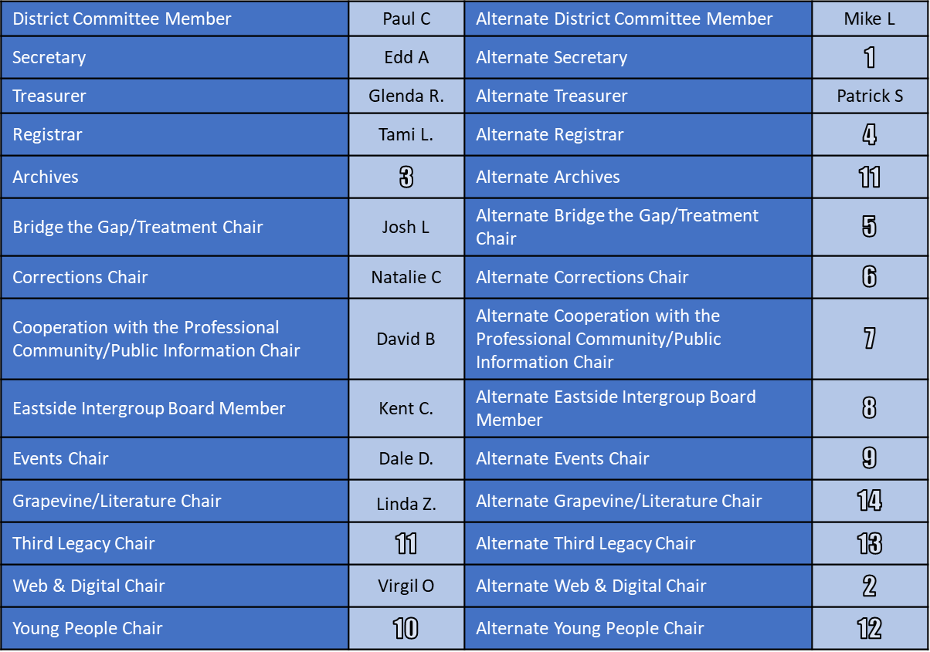

District Health
This comes out of the first two questions we answered in our inventory. Our district will be strongest, and our communication will be best when every group has a GSR and every GSR is attending our District 36 business meeting.

I’d like to leverage the work Tami has started and track which groups have a GSR for which we have valid contact information and which groups’ GSRs are attending the district business meeting. I’ll plan to include this in my report each month going forward.

Our action plan will be based on the groups still needing GSRs and the groups whose GSRs are not attending the district business meeting.

Gratitude Dinner
We are at a point in the year where we need to make a decision on having a Gratitude Dinner. I have heard that many people really enjoy the event. However, those sentiments have not been matched by the number of people willing to organize it.

If we have someone who will take accountability for organizing the event, we need to know who they are. It can be a very simple gathering and doesn’t have to follow what’s been done in prior years. If we don’t have anyone, it’s time to spread the word that we’re not having it and that we’re looking for someone to organize it in 2024.

Area Pre-Assembly Meetings
The pre-assembly is aimed at building an understanding of what will be discussed at the October Area 72 assembly. All district servants and GSR are encouraged to attend so that they can communicate topics to their groups and begin getting feedback for the assembly.

You are welcome to attend any pre-assembly which fits your schedule. Details are listed on the area website (www.area72aa.org)..

Area 72 Assembly
The area assembly will be held in October in Longview. All district servants and GSRs are encouraged to attend. Details and registration information are on the area website (www.area72aa.org).

District Guidelines Revision
We will review and revise our District 36 guidelines during this rotation. Please review the existing guidelines and, if you have any recommended revisions, send them to Mike and I. I am targeting a completed revision to put in front of district servants and GSRs at our business meeting in October.

We’re All In This Together
I value the time and effort each or you puts into service and to making sure that our groups are available and operating well for anyone who is looking for help. A couple of guiding principles I’d like to remind us of so that we make the best use of the valuable time all of us invest.
- Take initiative. If you’d like to see something get done, do it. If you make a mistake while doing so, we’ll figure out how to get it back on track together.
- We are there for each other. If someone is trying to do something to help the district and our groups, we support them. If it’s different from the way we’d do it, we demonstrate grace in constructively communicating an additional approach.

Please see the Area 72 event calendar at www.area72aa.org for details on all area events and for details on all committee chair quarterly meetings.

- Old Business
  - Hybrid meeting equipment update
  - District 36 Inventory follow up
  - Gratitude dinner
- New Business
No New Business
- Announcements. Mike L. informed the group that there is a service manual study in our district, it is held at Gail and Eddies house in Preston. If anyone is interested in attending please email me.
- Responsibility Statement
  - “I am responsible. When anyone, anywhere, reaches out for help, I want the hand of AA always to be there. And for that I am responsible.”

- Reminder for next District 36 Business Meeting
  - Tuesday, September 5th

