District 36 Treasurer’s Report May 2024
https://www.paypal.me/AADistrict36:
https://www.paypal.com/paypalme/AADistrict36
Month to Month Balance
- April 2024 $4,624.36
- May 2024 $3,499.04
Ledger March 2024
Date | Description | Category | Amount | Balance | Checking | Savings
3/28/2024 | DCM stickers, zoom (3) | DCM | -$176.44 | $4,624.36 | $4,120.30 | 504.06
3/31/2024 | Interest Savings | Interest | $0.21 | $4,624.57 | $4,120.30 | 504.27
3/31/2024 | Interest Checking | Interest | $0.35 | $4,624.92 | $4,120.65 | 504.27
3/31/2024 | Pay Pal ? .01 Jason Ramsdell Colville, WA | Unknown | $0.00 | $4,624.92 | $4,120.65 | 504.27 | issued refund - didn't look right
4/2/2024 | Group contrib. district meeting | Committee Seventh Tradition | $33.00 | $4,657.92 | $4,153.65 | 504.27
4/2/2024 | event contribution spring fling | Event contribution | $62.00 | $4,719.92 | $4,215.65 | 504.27
4/3/2024 | Gratitude Dinner site deposit | Gratitude Dinner | -$1,116.63 | $3,603.29 | $3,099.02 | 504.27 | reserve for Nov 2nd 2024 ck #1402
4/7/2024 | Alt DCM Assembly Bellingham | Alt DCM | -$222.00 | $3,381.29 | $2,877.02 | 504.27
4/7/2024 | Alt DCM Assembly Bellingham | Alt DCM | -$55.00 | $3,326.29 | $2,822.02 | 504.27
4/29/2024 | Zoom Account DCM |  | -$17.45 | $3,308.84 | $2,804.57 | 504.27
4/30/2024 | Interest Savings | Interest | $0.21 | $3,309.05 | $2,804.57 | 504.48
4/30/2024 | Interest Checking | Interest | $0.29 | $3,309.34 | $2,804.86 | 504.48
5/5/2024 | Group Contrib. Serentiy on Sunday N.Bend | Group Contribution | $120.00 | $3,429.34 | $2,924.86 | 504.48
5/5/2025 | Group contrib. Fri. Live Let Live Duvall | Group Contribution | $60.00 | $3,489.34 | $2,984.86 | 504.48
5/5/2024 | Paypal deposit | Committee Seventh Tradition | $9.70 | $3,499.04 | $2,994.56 | 504.48

BECU Accounts
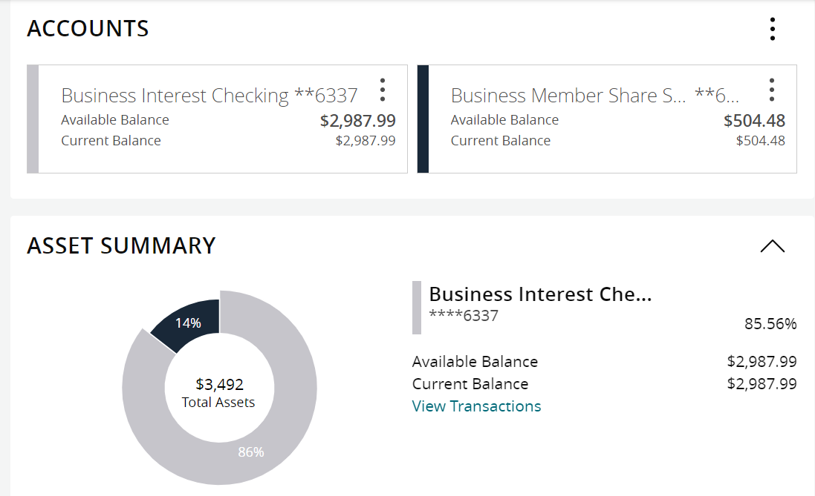

PayPal +9.70 from district contribution- transferred to BECU 5-5-24

Group Contributions
2024 | Totals |  | Jan | Feb | Mar | Apr | May
Alcathon | 164 |  | $109.00 | 55
As Bill Sees it
As Bill Sees it Online
BYOL (Bring Your Own Lunch)
The Camel and I
Came to Believe | 109.7 |  |  | 109.7
Carnation Home Group
Committee Seventh Tradition | 126.25 |  | $14.55 | 55 | 14 | 33 | 9.7
District Pay Pal Miscellaneous
Duvall Big Book Study
Duvall Candlelight 8pm
Duvall Sunday Morning Group | 135 |  |  | 135
Event 7th Tradition | 92 |  |  | 30 |  | 62
Forward to 164
Friday Fumblers
H.O.W. |  |  |  |  | 40
Live and Let Live Friday @ 6:30 | 169.5 |  | $72.00 |  | 37.5 | 60
Lunch with Bill W
Mt. Si Friday Night |  |  |  |  | 137.56
Mt Si Saturday Night |  |  |  |  | 137.56
North Bend Candle Light Thursday | 182 |  | $182.00
The Preston Group:One Hour Literature Study
Raging on the River
Right Side of the Tracks
Serenity on Sunday | 120 |  |  |  |  |  | 120
Sno Valley Women in Recovery Women
Snoqualmie Happy Hour
Snoqualmie Stag
SnoValley Young Peoples Meeting
Sober Rebels Joshua L/Thursday
Step Sisters Women
Stillwater Serenity
Surrender on Sunday
Swing Shift
That 12 and 12 Meeting
Women's Sunlight of The Spirit Women
William W | 100 |  | $100.00
Total | 1198.45 |  | $477.55 | 384.7 | 366.62 | 155

2024 Budget
2024Budget | Budget 2024 |  |  | Actions GR
 | Budgeted | Actual | Budget meeting notes / changes sched budget meeting January 30th ,2024 | break out income - grat. Alcoh.. , check storage,
DCM | $800.00 | $154.14 | Was 700.00 | 124.14 Stickers, 30.00 Quarterly,
Alt DCM | $800.00 | $312.00 | Was 500.00 | 35.00 Quarterly , 55.00/222.00 Assembly
district technology, printing | $300.00 | $349.00 | New this year | projector 349.00,
Online technology | $300.00 | $174.28 | New this year | 52.29 - zoom 230.00 zoom, (webhost - 156.83, 17.45 zoom, )
Secretary | $25.00
ESIG | $25.00
Treasurer | $75.00
Bridge the Gap | $25.00
Grapevine and Literature | $300.00 | $118.58 |  | 3-5-23 Grapevine phamplet 52.14, schedules 66.44
CPC/PI | $100.00
Treatment | $100.00
Accessibility | $75.00
Registrar | $50.00 |  | Was 25.00
Alcothon | $50.00
Workshops | $200.00
Events | $300.00
Gratitude Dinner | $1,500.00 | $1,163.63
Webmaster | $25.00 |  | was 250.00 broke out in line 6.
Corrections | $100.00
Storage | $480.00 | $240.00 | 240 | Due Jan /June
Rent | $240.00
PO Box | $176.00
Young People in A.A. | $100.00
Total | $6,146.00
Total Budget PR | $1,736.50
Rounded | $2,000.00

