District 36 Treasurer’s Report April 2024
https://www.paypal.me/AADistrict36:
https://www.paypal.com/paypalme/AADistrict36
Month to Month Balance
- March 2024 $4,345.56 – should have been $ 4901.76
- April 2024 $4,624.36
Ledger March 2024
Date | Description | Category | Amount | Balance | Checking | Savings
3/3/2024 | Area quarterly | DCM | -$30.00 | $5,176.56 | $4,672.70 | 503.86
3/3/2024 | Area quarterly | Alt DCM | -$35.00 | $5,141.56 | $4,637.70 | 503.86
2/29/2024 | Interest Savings | Interest | $0.20 | $5,141.76 | $4,637.70 | 504.06
3/4/2024 | District Storage | Storage | -$240.00 | $4,901.76 | $4,397.70 | 504.06
3/10/2024 | District Technology Projector | Technology | -$349.00 | $4,552.76 | $4,048.70 | 504.06
3/6/2024 | District Printing schedule | Literature | -$66.44 | $4,486.32 | $3,982.26 | 504.06
3/5/2024 | District Grapevine (Spanish) | Literature | -$52.14 | $4,434.18 | $3,930.12 | 504.06
3/25/2024 | Group contrib. district meeting | Committee Seventh Tradition | $14.00 | $4,448.18 | $3,944.12 | 504.06
3/25/2024 | Group contrib. HOW 7236165356 | Group Contribution | $40.00 | $4,488.18 | $3,984.12 | 504.06
3/25/2024 | Group contrib. Fri. Live Let Live Duvall | Group Contribution | $37.50 | $4,525.68 | $4,021.62 | 504.06
3/31/2024 | Group Contrib. Mt. Si Friday Night #125 | Group Contribution | $137.56 | $4,663.24 | $4,159.18 | 504.06
3/31/2024 | Group Contrib. Mt. Si Saturday Night #126 | Group Contribution | $137.56 | $4,800.80 | $4,296.74 | 504.06
3/28/2024 | DCM stickers, zoom (3) | DCM | -$176.44 | $4,624.36 | $4,120.30 | 504.06
3/31/2024 | Interest Savings | Interest
3/31/2024 | Interest Checking | Interest
3/31/2024 | Pay Pal ? .01 Jason Ramsdell Colville, WA | Unknown | $0.00
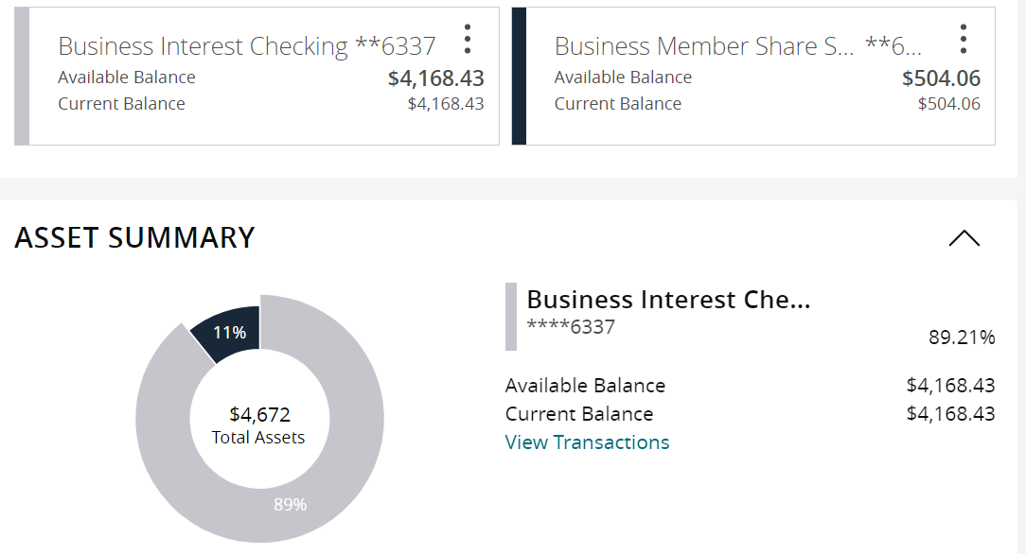

PayPal NA - .01 deposit / refunded didn’t look right.

Contributions
2024 | Totals |  | Jan | Feb | Mar | Apr | Notes
Alcathon | 164 |  | $109.00 | 55
As Bill Sees it |  |  |  |  |  |  | zero in 2023
As Bill Sees it Online |  |  |  |  |  |  | 58.2 in 2023
BYOL (Bring Your Own Lunch) |  |  |  |  |  |  | zero in 2023
The Camel and I
Came to Believe | 109.7 |  |  | 109.7
Carnation Home Group |  |  |  |  |  |  | zero in 2023
Committee Seventh Tradition | 83.55 |  | $14.55 | 55 | 14
District Pay Pal Miscellaneous
Duvall Big Book Study |  |  |  |  |  |  | Zero in 2023
Duvall Candlelight 8pm |  |  |  |  |  |  | 102.15 in 2023
Duvall Sunday Morning Group | 135 |  |  | 135
Event 7th Tradition | 30 |  |  | 30
Forward to 164 |  |  |  |  |  |  | zero 2023
Friday Fumblers |  |  |  |  |  |  | 28.00 2023
H.O.W. |  |  |  |  | 40
Live and Let Live Friday @ 6:30 | 109.5 |  | $72.00 |  | 37.5
Lunch with Bill W |  |  |  |  |  |  | zero in 2023
Mt. Si Friday Night |  |  |  |  | 137.56
Mt Si Saturday Night |  |  |  |  | 137.56
North Bend Candlelight Thursday | 182 |  | $182.00
The Preston Group: One Hour Literature Study
Raging on the River |  |  |  |  |  |  | Zero in 2023
Right Side of the Tracks |  |  |  |  |  |  | 100.00 2023
Serenity on Sunday |  |  |  |  |  |  | 60.00 in 2023
Sno Valley Women in Recovery Women
Snoqualmie Happy Hour |  |  |  |  |  |  | zero 2023
Snoqualmie Stag |  |  |  |  |  |  | 500+ 2023
2024 | Totals |  | Jan | Feb | Mar | Apr | Notes
SnoValley Young Peoples Meeting
Sober Rebels Joshua L/Thursday |  |  |  |  |  |  | 140+ 2023
Step Sisters Women
Stillwater Serenity |  |  |  |  |  |  | 200+ 2023
Surrender on Sunday
Swing Shift
That 12 and 12 Meeting |  |  |  |  |  |  | zero 2023
Women's Sunlight of The Spirit Women
William W | 100 |  | $100.00
Total | 913.75 |  | $477.55 | 384.7 | 366.62

2024 Budget
2024Budget | Budget 2024 |  |  | Actions GR
 | Budgeted | Actual | Budget meeting notes / changes sched budget meeting January 30th ,2024 | break out income - grat. Alcoh.. , check storage,
DCM | $800.00 | $154.14 | Was 700.00 | 124.14 Stickers, 30.00 Quarterly,
Alt DCM | $800.00 | $35.00 | Was 500.00 | 35.00 Quarterly
district technology, printing | $300.00 | $349.00 | New this year | projector 349.00,
Online technology | $300.00 | $156.83 | New this year | 52.29 - zoom 230.00 zoom, webhost - 156.83
Secretary | $25.00
ESIG | $25.00
Treasurer | $75.00
Bridge the Gap | $25.00
Grapevine and Literature | $300.00 | $118.58 |  | 3-5-23 Grapevine phamplet 52.14, schedules 66.44
CPC/PI | $100.00
Treatment | $100.00
Accessibility | $75.00
Registrar | $50.00 |  | Was 25.00
Alcothon | $50.00
Workshops | $200.00
Events | $300.00
Gratitude Dinner | $1,500.00
Webmaster | $25.00 |  | was 250.00 broke out in line 6.
Corrections | $100.00
Storage | $480.00 | $240.00 | 240 | Due Jan /June
Rent | $240.00
PO Box | $176.00
Young People in A.A. | $100.00
Total | $6,146.00
Total Budget PR | $1,736.50
Rounded | $2,000.00

