<https://www.paypal.me/AADistrict36>:

<https://www.paypal.com/paypalme/AADistrict36>

**Month to Month Change**

**Sept 2023** **$4,501.79**

**October 2023**  **$3,648.22**

** Received Check not deposited –Front Street …. no group listed or person (person does wk at Costco)

* **Please ask your groups again???**

**Ledger**

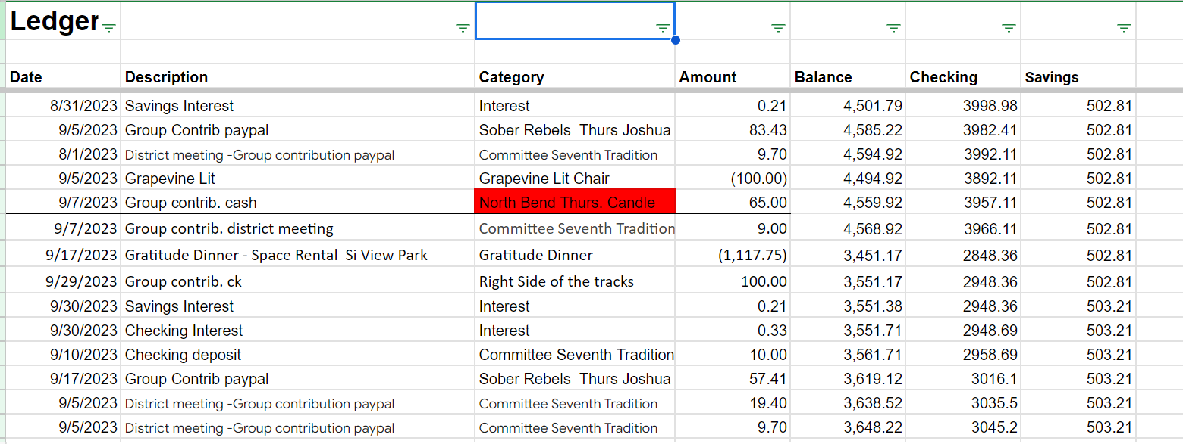

**BECU Balance 2023 10-2-23**

|  |  |
| --- | --- |
| **Checking 3127.53** | **Savings 503.21** |

Checking | Savings 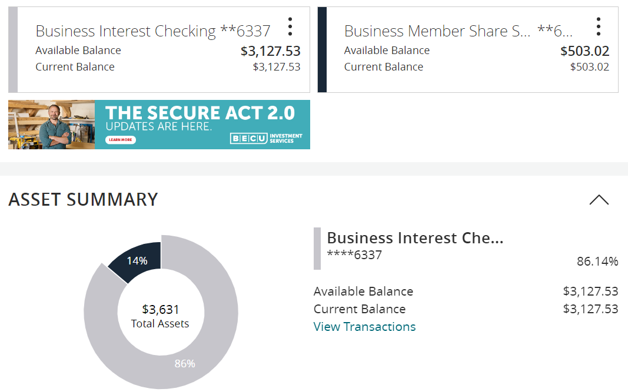

**Supplies / Ledger**

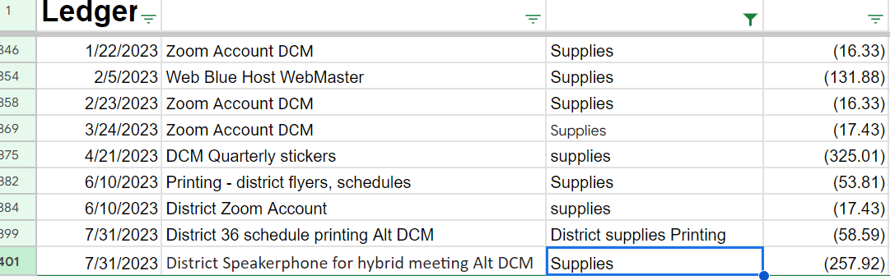

**2023 Budget 10-2-23**

