<https://www.paypal.me/AADistrict36>:

<https://www.paypal.com/paypalme/AADistrict36>

**Month to Month Change**

**August 2023** **$3,857.24**

**Sept 2023** **$4,072.50**

**Ledger**

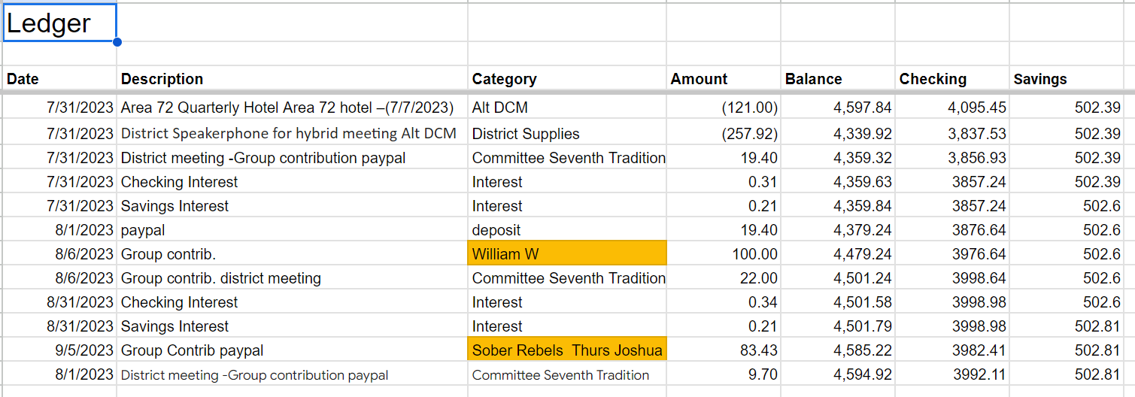

** William W – Don't know which group he is from

** Sober Rebels – New Group added to ledger

** Received Check not deposited –Front Street …. no group listed or person (person does wk at Costco)

**BECU Balance 2023 9-5-23**

|  |  |
| --- | --- |
| **4072.50** | **502.81** |

Checking | Savings

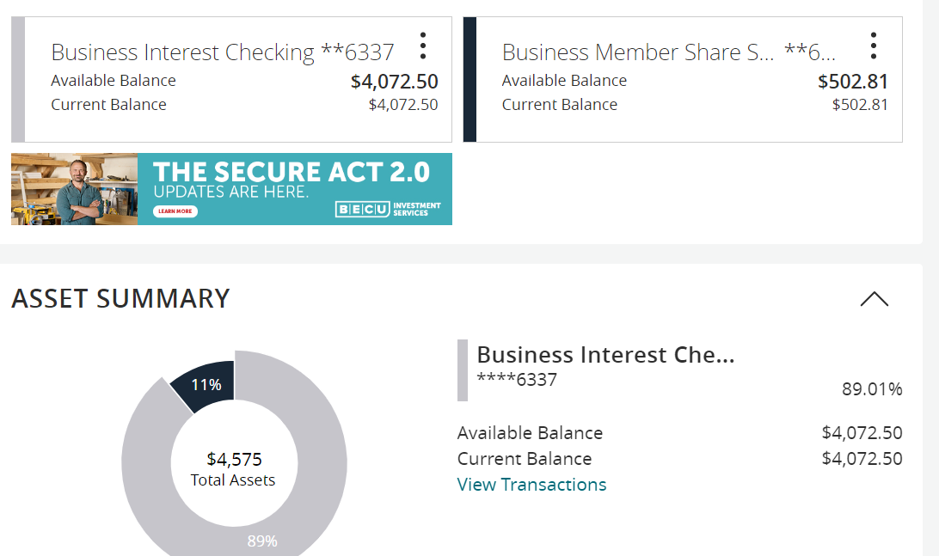

**2023 Budget 9-5-23**

**Not updated Treasure needs to review and align charges.**

|  |  |  |  |  |  |  |
| --- | --- | --- | --- | --- | --- | --- |
| 2023 Budget |  |  |  |  |  |  |
|  |  |  |  |  |  |  |
|  | **Budgeted** | **Actual** |  |  | Budget meeting notes / changes |  |
| DCM | 700.00 | 452.53 |  |  |  |  |
| Alt DCM | 500.00 | 452.81 |  |  |  |  |
| Secretary | 25.00 |  |  |  | from 75 to 25 |  |
| ESIG | 25.00 |  |  |  | from 75 to 25 |  |
| Treasurer | 75.00 | 40.00 |  |  |  |  |
| Bridge the Gap | 75.00 |  |  |  |  |  |
| Grapevine and Literature | 300.00 |  |  |  |  |  |
| CPC/PI | 300.00 |  |  |  |  |  |
| Treatment | 100.00 |  |  |  | from 300 to 100 |  |
| Accessibility | 75.00 |  |  |  |  |  |
| Registrar | 25.00 |  |  |  |  |  |
| Alcothon | 50.00 | (109.79) |  |  | from 75 to 50 |  |
| Workshops | 200.00 |  |  |  |  |  |
| Events | 300.00 |  |  |  |  |  |
| Gratitude Dinner | 1,500.00 |  |  |  |  |  |
| Webmaster | 250.00 | 131.88 |  |  |  |  |
| Corrections | 100.00 |  |  |  |  |  |
| Storage | 480.00 | 240.00 |  |  |  |  |
| Rent | 240.00 |  |  |  |  |  |
| PO Box | 100.00 |  |  |  |  |  |
| Young People in A.A. | 100.00 |  |  |  |  |  |
| **Total** | **5,520.00** | **1,207.43** |  |  |  |  |
|  |  |  |  |  |  |  |
| Total Budget PR | 2,822.50 |  |  |  |  |  |
| plus 200 suggested in the guidelines doc | 3,022.50 |  |  |  |  |  |
| Rounded | 3,000.00 |  |  |  |  |  |

**Group Contributions 9-5-23**

