District 36 Treasurer’s Report Feb 2024
https://www.paypal.me/AADistrict36:
https://www.paypal.com/paypalme/AADistrict36
Month to Month Balance
- January 2024 $4,619.55
- February 2024 $4,896.50

Date | Description | Category | Amount | Balance | Checking | Savings
12/31/2023 | Interest Checking | Interest | $0.36 | $4,619.55 | $4,116.11 | $503.44
12/31/2023 | Interest Savings | Interest | $0.21 | $4,619.76 | $4,116.11 | 503.65
1/3/2024 | Group contrib. cash 16/11/18.00 Thurs Candle North Bend | Group Contribution | $45.00 | $4,664.76 | $4,161.11 | 503.65
1/3/2024 | Alcathon group contrib. | Group Contribution | $109.00 | $4,773.76 | $4,270.11 | 503.65
1/3/2024 | member contrib. cash | Group Contribution | $28.00 | $4,801.76 | $4,298.11 | 503.65
1/29/2024 | Group contrib. ck 9005, William W | Group Contribution | $100.00 | $4,901.76 | $4,398.11 | 503.65
2/5/2024 | Line 99 ck for PO never cashed - we paid with card. | P.O Box | $176.00 | $5,077.76 | $4,574.11 | 503.65
1/5/2024 | book purchase | Stories disclosed | $25.00 | $5,102.76 | $4,599.11 | 503.65
1/27/2024 | Blue Host Web | Online Technology | -$156.83 | $4,945.93 | $4,442.28 | 503.65
2/4/2024 | Tax filing | Treasurer | -$50.00 | $4,895.93 | $4,392.28 | 503.65
2/6/2024 | Interest Checking | Interest | $0.36 | $4,896.29 | $4,392.64 | 503.65
2/6/2023 | Interest Savings | Interest | $0.21 | $4,896.50 | $4,392.64 | 503.86
2/6/2024 | Interest Savings | Interest | $0.21 | $4,896.50 | $4,392.64 | 503.86
Ledger

BECU Balance Feb 2024
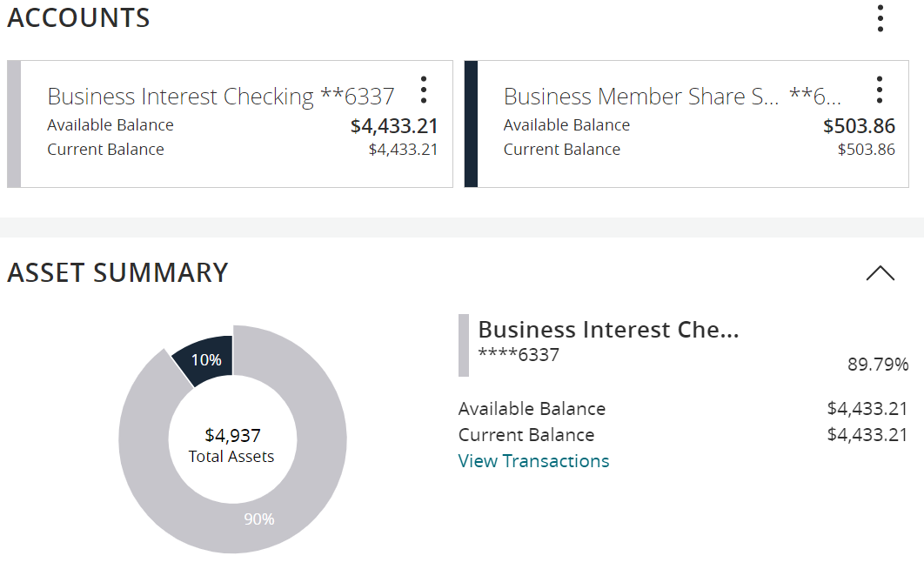

2023 Gratitude Dinner
 |  |  | $1500.00 Budgeted Amount
Date | Description | Amount | Balance
9-29-23 | Space Rental Si View Park | -$1,117.75 | $382.25
11/20/2023 | 7th Tradition | $355.00 | $737.25
11/20/2023 | Raffle | $521.00 | $1,258.25
11/20/2023 | Tickets onsite/@door | $509.00 | $1,767.25
11/20/2023 | Baby sitter | -$200.00 | $1,567.25
11/11/2023 | Reimbursement Coffee | -$112.45 | $1,454.80
11/20/2023 | Ticket online 11-11-23 PayPal 72.18/19.40/1.52/15.52 | $122.62 | $1,686.80
12/5/2023 | event bright ticket sales | $411.75 | $2,098.55
 | 50/50 payout - Glenda NA
11/13/2023 | Damage deposit refund | $250.00 | $2,348.55

Contributions
Updated List of Contributions 2024 | Totals | Jan | Feb
Unknown group | $100.00 |  | $100.00
Alcathon | $109.00 | $109.00
As Bill Sees it
As Bill Sees it Online
BYOL (Bring Your Own Lunch)
Came to Believe
Carnation Home Group
Committee Seventh Tradition | $14.55 | $14.55
District Pay Pal Miscellaneous
Duvall Big Book Study
Duvall Candlelight | $72.00 | $72.00
Duvall Sunday Morning Group
Event 7th Tradition
Forward to 164
Friday Fumblers
H.O.W. Women's Meeting
Live and Let Live (Friday Duvall)
Lunch with Bill W
Mt Si Group Friday Snoqualmie
Mt Si Saturday Night Fall City
North Bend Candle Light Thursday | $182.00 | $182.00
The Preston Group:One Hour Literature Study
Raging on the River
Right Side of the Tracks
Serenity on Sunday
Sno-Valley Women in recovery
Snoqualmie Happy Hour
Sno Valley Young Peoples North Bend
Snoqualmie Valley Happy Hour Zoom meeting
Snoqualmie Stag
Sober Rebels Joshua L/Thursday
Step Sisters
Stillwater Serenity
Surrender on Sunday
Swing Shift
The 12 and 12 Meeting
The Camel & I
Women's sunlight of the spirit
Total | $477.55 | $377.55
2024 Budget

2024Budget | Budget 2024 |  | Updated Info
 | Budgeted | Actual | Budget meeting notes / changes sched budget meeting January 30th ,2024
DCM | $800.00 |  | Was 700.00
Alt DCM | $800.00 |  | Was 500.00
district technology, printing | $300.00 |  | New this year
Online technology | $300.00 | $156.83 | New this year
Secretary | $25.00
ESIG | $25.00
Treasurer | $75.00
Bridge the Gap | $25.00
Grapevine and Literature | $300.00
CPC/PI | $100.00
Treatment | $100.00
Accessibility | $75.00
Registrar | $50.00 |  | Was 25.00
Alcothon | $50.00
Workshops | $200.00
Events | $300.00
Gratitude Dinner | $1,500.00
Webmaster | $25.00 |  | was 250.00 broke out in line 6.
Corrections | $100.00
Storage | $480.00 |  | 240
Rent | $240.00
PO Box | $176.00
Young People in A.A. | $100.00
Total | $6,146.00
Total Budget PR | $1,736.50
Rounded | $2,000.00

