**District 36 Treasurer’s Report November 2023**

<https://www.paypal.me/AADistrict36>:

<https://www.paypal.com/paypalme/AADistrict36>

**Month to Month**

**October 2023** $3,649.95

**November 2023**  $2,922.63

**Ledger**

|  |  |  |  |  |  |  |
| --- | --- | --- | --- | --- | --- | --- |
| **Date** | **Description** | **Category** | **Amount** | **Balance** | **Checking** | **Savings** |
| 9/5/2023 | District meeting -Group contribution PayPal | Committee Seventh Tradition | $1.94 | $3,649.95 | $3,146.46 | $503.02 |
| 10/4/2023 | Cash in the basket | Committee Seventh Tradition | $18.00 | $3,667.95 | $3,164.46 | $503.02 |
| 10/15/2023 | Annual report with the State of Washington | Treasurer | -$20.00 | $3,647.95 | $3,144.46 | $503.02 |
| 10/16/2023 | Storage ck 1394 10-25-34 | Storage | -$240.00 | $3,407.95 | $2,904.46 | $503.02 |
| 10/2/2023 | District technology BECU CC Alt DCM speakers | Alt DCM | -$45.74 | $3,362.21 | $2,858.72 | $503.02 |
| 10/5/2023 | District technology ck 1993 Alt DCM speakers | Alt DCM | -$135.28 | $3,226.93 | $2,723.44 | $503.02 |
| 10/29/2023 | Mike L ck 1395 area assembly reg/meals | Alt DCM | -$154.00 | $3,072.93 | $2,569.44 | $503.02 |
| 10/8/2023 | Lodging Alt DCM /DCM BECU cc | DCM / Alt DCM | -$255.30 | $2,817.63 | $2,314.14 | $503.02 |
| 9/5/2023 | PayPal deposit | Group Contribution | $93.13 | $2,910.76 | $2,407.27 | $503.02 |
| 10/30/2023 | PayPal deposit | Group Contribution | $11.64 | $2,922.40 | $2,418.91 | $503.02 |
| 10/31/2023 | Interest Checking | interest | $0.23 | $2,922.63 | $2,419.14 | $503.02 |

**BECU Balance November 6th, 2023**

|  |  |
| --- | --- |
| **Checking $2,461.08** | **Savings $503.23** |

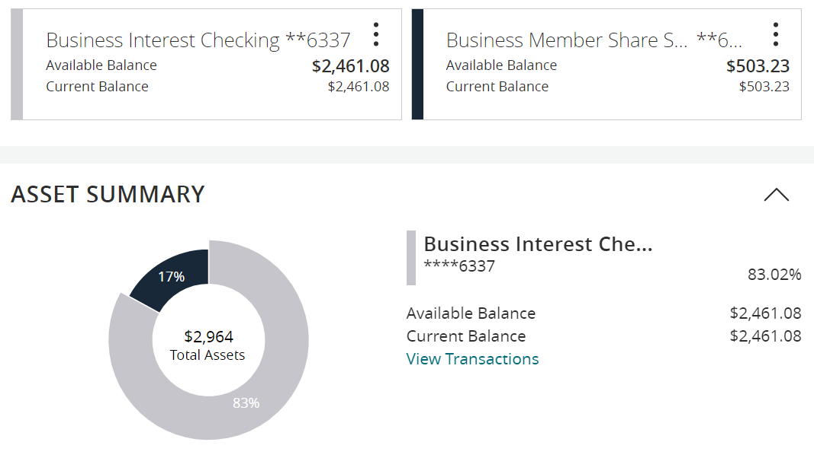

**2023 Budget November 6th, 2023**

|  |  |  |  |  |
| --- | --- | --- | --- | --- |
| **2023 Budget** |  |  |  |  |
|  | **Budgeted** | **Actual** | Budget meeting notes / changes 12-22 | **Treasurer Notes 11-23** |
| DCM | $700.00 | $1,104.34 |  | Includes district technology, printing |
| Alt DCM | $500.00 | $674.07 |  |  |
| Secretary | $25.00 | $0.00 | from 75 to 25 |  |
| ESIG | $25.00 | $0.00 | from 75 to 25 |  |
| Treasurer | $75.00 | $60.00 |  |  |
| Bridge the Gap | $75.00 | $0.00 |  |  |
| Grapevine and Literature | $300.00 | $100.00 |  |  |
| CPC/PI | $300.00 | $0.00 |  |  |
| Treatment | $100.00 | $0.00 | from 300 to 100 |  |
| Accessibility | $75.00 | $0.00 |  |  |
| Registrar | $25.00 |  |  |  |
| Alcothon | $50.00 | $20.21 | from 75 to 50 |  |
| Workshops | $200.00 |  |  |  |
| Events | $300.00 |  |  |  |
| Gratitude Dinner | $1,500.00 | $1,117.75 |  |  |
| Webmaster | $250.00 | $131.88 |  |  |
| Corrections | $100.00 | $0.00 |  |  |
| Storage | $480.00 | $480.00 |  |  |
| Rent | $240.00 | $240.00 |  |  |
| PO Box | $100.00 | $88.00 |  |  |
| Young People in A.A. | $100.00 | $0.00 |  |  |
| Total | $5,520.00 | $4,016.25 |  |  |
|  |  |  |  |  |
| Total Budget PR | $2,822.50 |  |  |  |
| plus 200 suggested in the guideline's doc | $3,022.50 |  |  |  |
| Rounded | $3,000.00 |  |  |  |

**Gratitude Dinner November 6th, 2023**

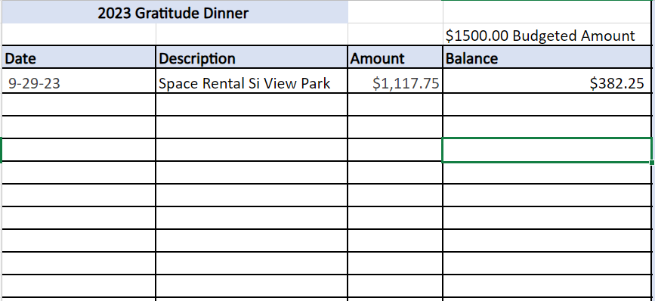

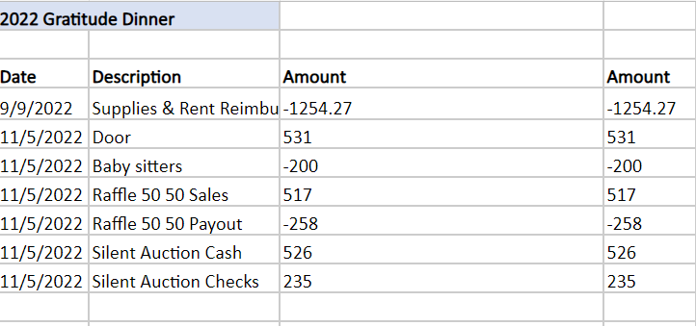

**Group Contributions November 6th, 2023**

***\*\*\*Orange Colour*** – Treasurer will update /cross reference with Registrar.

|  |  |  |  |  |  |  |  |  |  |  |  |
| --- | --- | --- | --- | --- | --- | --- | --- | --- | --- | --- | --- |
| **2023** | **Totals** |  | **Jan** | **Feb** | **Mar** | **Apr** | **May** | **Jun** | **Jul** | **Aug** | **Sep** |
| Unknown group | $128.00 |  |  | $28.00 |  |  |  |  |  | $100.00 |  |
| 60 Minutes in Preston |  |  |  |  |  |  |  |  |  |  |  |
| AA Newcomers |  |  |  |  |  |  |  |  |  |  |  |
| Alcothon | $130.00 |  | $130.00 |  |  |  |  |  |  |  |  |
| As Bill Sees it |  |  |  |  |  |  |  |  |  |  |  |
| As Bill Sees it Online | $58.20 |  | $19.40 | $19.40 | $19.40 |  |  |  |  |  |  |
| BYOL (Bring Your Own Lunch) |  |  |  |  |  |  |  |  |  |  |  |
| Came to Believe | $255.61 |  |  |  |  |  |  | $61.64 | $114.47 | $79.50 |  |
| Carnation Home Group |  |  |  |  |  |  |  |  |  |  |  |
| Come As You Are Part 2 |  |  |  |  |  |  |  |  |  |  |  |
| Committee Seventh Tradition | $109.42 |  | $9.70 | $34.82 | $21.29 | $12.61 | $9.70 | $0.00 | $19.40 | $22.00 | $9.00 |
| District Pay Pal Miscellaneous |  |  |  |  |  |  |  |  |  |  |  |
| Duvall Big Book Study |  |  |  |  |  |  |  |  |  |  |  |
| Duvall Candlelight | $102.15 |  |  | $68.65 |  |  |  |  | $33.50 |  |  |
| Duvall Sunday Morning Group |  |  |  |  |  |  |  |  |  |  |  |
| Event 7th Tradition |  |  |  |  |  |  |  |  |  |  |  |
| Forward to 164 |  |  |  |  |  |  |  |  |  |  |  |
| Friday Fumblers | $28.00 |  | $28.00 |  |  |  |  |  |  |  |  |
| H.O.W. | $25.00 |  |  |  |  |  |  |  | $25.00 |  |  |
| Live and Let Live |  |  |  |  |  |  |  |  |  |  |  |
| Lunch with Bill W |  |  |  |  |  |  |  |  |  |  |  |
| Middle of the Pack |  |  |  |  |  |  |  |  |  |  |  |
| Mt Si Saturday Night |  |  |  |  |  |  |  |  |  |  |  |
| North Bend Group | $100.00 |  |  |  | $100.00 |  |  |  |  |  |  |
| North Bend Candle Light Thursday | $65.00 |  |  |  |  |  |  |  |  |  | $65.00 |
| North Bend Newcomers |  |  |  |  |  |  |  |  |  |  |  |
| On Awakening |  |  |  |  |  |  |  |  |  |  |  |
| Raging on the River |  |  |  |  |  |  |  |  |  |  |  |
| Resentment and a Coffee Pot |  |  |  |  |  |  |  |  |  |  |  |
| Right Side of the Tracks | $100.00 |  |  |  |  |  |  |  |  |  | $100.00 |
| Serenity on Sunday | $60.00 |  |  | $60.00 |  |  |  |  |  |  |  |
| Sno-Valley |  |  |  |  |  |  |  |  |  |  |  |
| Snoqualmie Friday Night |  |  |  |  |  |  |  |  |  |  |  |
| Snoqualmie Happy Hour |  |  |  |  |  |  |  |  |  |  |  |
| Snoqualmie Stag | $312.70 |  | $105.00 | $144.00 | $140.69 |  | $168.70 |  |  |  |  |
| Sober on the Ridge |  |  |  |  |  |  |  |  |  |  |  |
| Sober Valley Wednesday |  |  |  |  |  |  |  |  |  |  |  |
| Sober Rebels Joshua L/Thursday | $140.84 |  |  |  |  |  |  |  |  | $83.43 | $57.41 |
| Solutions Group |  |  |  |  |  |  |  |  |  |  |  |
| SOS (Sober on Sunday) |  |  |  |  |  |  |  |  |  |  |  |
| Stillwater Serenity | $200.00 |  |  | $100.00 |  |  |  |  | $100.00 |  |  |
| Sunday Night Stag |  |  |  |  |  |  |  |  |  |  |  |
| Sunlight of the Spirit |  |  |  |  |  |  |  |  |  |  |  |
| That 12 and 12 Meeting |  |  |  |  |  |  |  |  |  |  |  |
| Tuesday Hope |  |  |  |  |  |  |  |  |  |  |  |
| Valley Young and Sober |  |  |  |  |  |  |  |  |  |  |  |
| Mike S 1650 | $600.00 |  | $100.00 |  |  |  |  |  | $500.00 |  |  |
| **Total** | **$2,414.92** |  | **$392.10** | **$454.87** | **$140.69** | **$12.61** | **$178.40** | **$61.64** | **$792.37** | **$284.93** | **$231.41** |