District 36 Business meeting August 2024 Minutes & Reports
In attendance- Mike, Paul, Kent, Derek, Kent, Patrick, Jerry, Glenda, Eric.
Birthdays – Eric with 3 yrs
Gratitude Dinner – Brian and Jerry. Nov 2nd Mt Si community Center
ESIG- Mariner’s tickets available for Sober event – Sept 15th. They need allot of help look at website.
Treasurer’s report – approved.
Allot of district open positions
Alt DCM – requested $75.00 for a portable screen for the district – discussed and approved.
Pre Assy – August 17th / setup at 9 , need your help all day.
District Elections – Nov
Event this sat – fun on the farm Duvall – on website
Reports

DCM
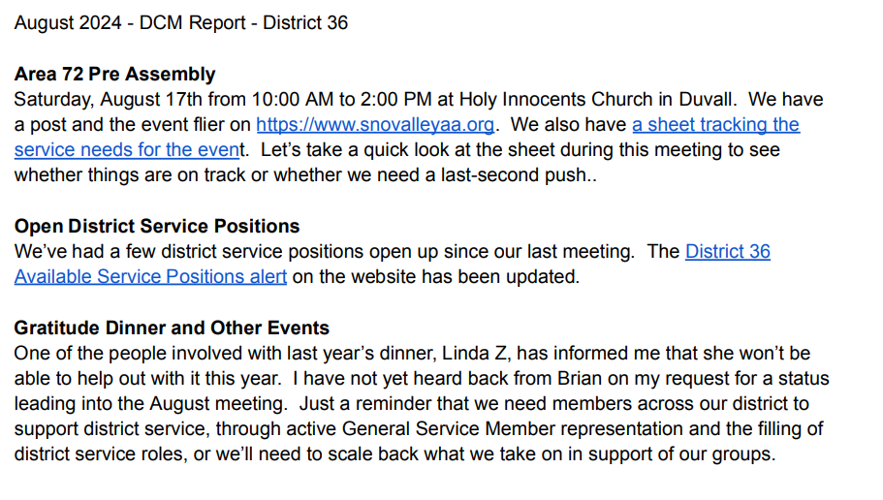

August 2024 - Alt DCM Report – District 36
· Attended Area 72 Business Quarterly in Lacey (July 6) o Business summary: https://area72aa.org/wp-content/uploads/2024/07/1b-July-2024-Quarterly-Summary-final-7-9-24-eng.pdf o Meeting minutes: https://area72aa.org/wp-content/uploads/2024/07/1c-July-2024-Quarterly-Minutes-Final.pdf
· Planning for the August Pre-Assembly for Eastside Districts. Saturday, August 17 from 10am to 2pm at Holy Innocents Church in Duvall. o Flyer and info at https://snovalleyaa.org/eastside-districts-pre-assembly-will-be-on-saturday-august-17th-at-holy-innocents-church-in-duvall/
o Plan for Zoom and Hybrid meeting portion with John B and Mario M.
o Got some volunteers from Duvall/Carnation groups. Need a few more people that can commit to cleaning and restore area for Church use.
o Volunteer signup: https://docs.google.com/spreadsheets/d/11Tnvv8tqVfT42REkr9ZBjsSc0eUg504rKAD9RBoEQfs/edit?gid=897642624#gid=897642624 · Upcoming Area 72 events: https://area72aa.org/events/ o Aug 17 Eastside Districts Pre-Assembly: https://area72aa.org/event/2024-eastside-districts-pre-assembly/ o Aug 23 Online Pre-assembly: https://area72aa.org/event/2024-online-pre-assembly/ o Aug 24 Central Districts (Seattle) Pre-assembly: https://area72aa.org/event/2024-central-districts-pre-assembly/
o Sept 8 (10 am until noon) online GSR Workshop. For anyone currently in GSR position or interested in GSR: https://area72aa-org.zoom.us/j/86909224901?pwd=UnF0dE5NVVkzYzhFTzVaN3B3SVQ1QT09 Meeting ID: 869 0922 4901 Passcode: GSR2024
· The district print schedule is available on our website.
o Lists meetings in the valley
o Web addresses for Eastside Intergroup, Western Washington Area 72, and GSO o https://snovalleyaa.org/wp-content/uploads/2024/02/AA-schedule1_D36_20240206.pdf

Service Opportunities from the Seattle Intergroup Hospital & Treatment committee minutes.
King County Residential Program: I spoke with Douglas N last week regarding setting up panels 2X's a week at his facility (King County Residential Program). I will be going to their facility on Beacon Hill on Mon, August 19th. They are interested in purchasing literature, pamphlets and would like a meeting starter kit. Doug will be speaking with his Director about available time slots for panels.
Bread of Life Mission: The new Bread of Life Mission meeting launched on Sat, July 13th! This weekly AA meeting is happening at 11:45 am in the dining room of their Pioneer Square facility! Tom W led all 3 Saturdays and had support by several of you as well. Let's ramp up the support and make it a success!
Union Gospel Mission: We started a weekly Saturday morning meeting at Downtown GM a few months ago. So we are now holding weekly meetings at both UGM's Riverton Place (Thurs nights at 6 pm) and Downtown UGM (Sat mornings at 10 am). We continue to look for guys to get involved in Secretarying and /or Chairing both of these meetings and we also hold a speaker's panel on second Thurs nights at Riverton Place.
Union Gospel Mission's Hope Place, a women's recovery facility in D15 and have women scheduled to speak there in October. They have indicated they want every other month now to allow their staff to share testimony as well. You must be pre-registered to enter any UGM facility and have an active account so please talk to West if you are interested in getting involved.
Key Recovery: We continue to carry evening panels to Key Recovery on the weekends as well as Tuesday nights. The weekend evening panels happen upstairs in an intimate setting with residents with over 6 months of sobriety who are looking for work. Our Tuesday night panels happen downstairs with many newcomers with less than 6 months sobriety.
Lakeside Milam: We have our Lakeside Milam Renton panel every final Friday of the month at 9 am and we just added a 6 pm panel on last Wednesdays. We continue to bring in a panel to Lakeside Milam Auburn every second Tues @ 7 pm.
Harborview: We continue to carry our message of hope to Harborview's 5th Floor Inpatient Psychiatric Unit every Sunday night at 5:15 pm. We now have 19 volunteers cleared to panel there and I sent out a new script to everyone and we will keep one behind the desk in % West.
Salvation Army: All are welcome at our weekly Salvation Army Sunday night 7 pm meeting at the William Booth Center, so please come support this meeting and bring a friend. We are rotating Secretaries weekly and always looking for folks to chair that meeting as well. A big thank you goes to Jeff U & Mike C from GSIG for their help and also Riverton Place for bringing a van full of guys every Sunday!
Olympic Heritage Behavioral Health: We are currently on hold but should be able to start a Tuesday night meeting there soon. The launch date has been put off until at least September and anyone interested must have completed a background check before entering the facility. More will be revealed!
The best way to get involved in any of these projects is to attend our H & T Committee hybrid meeting every first Saturday of the month. The meeting is located at GSIG 6th & Lucille in Georgetown & also on Zoom. Please contact West C if you are interested in getting involved at 425-736- 4130 or hospitalandtreatment@seattleaa.org.

District 36 Treasurer’s Report August 2024
https://www.paypal.me/AADistrict36:
https://www.paypal.com/paypalme/AADistrict36
Month to Month Balance
- July 2024 $3,194.07
- August 2024 $3,173.90
Ledger
Date | Description | Category | Amount | Balance | Checking | Savings
7/1/2024 | Group Contrib Sober Rebels | Group Contribution | $147.46 | $3,194.07 | $2,689.17 | 504.9
8/4/2024 | Group Contrib. Sno Valley Women in Recovery | Group Contribution | $21.00 | $3,215.07 | $2,710.17 | 504.9
8/4/2024 | Group Contrib. Tuesday Night Happy | Group Contribution | $75.00 | $3,290.07 | $2,785.17 | 504.9
8/4/2024 | Paypal deposit | Group Contribution | $9.70 | $3,299.77 | $2,794.87 | 504.9
8/4/2024 | Interest Checking | Interest | $0.24 | $3,300.01 | $2,795.11 | 504.9
8/4/2024 | Interest Savings | Interest | $0.21 | $3,300.25 | $2,795.11 | 505.11
7/6/2024 | Zoom | Technology | -$17.45 | $3,282.80 | $2,777.66 | 505.11
7/6/2024 | Printing | event Pre assy | -$108.90 | $3,173.90 | $2,668.76 | 505.11

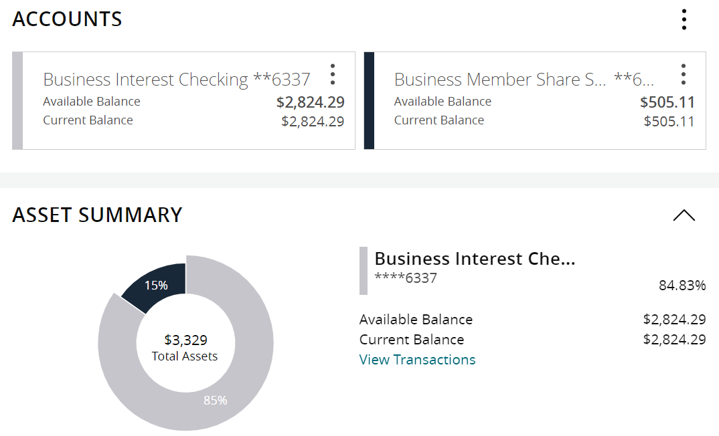

Group Contributions
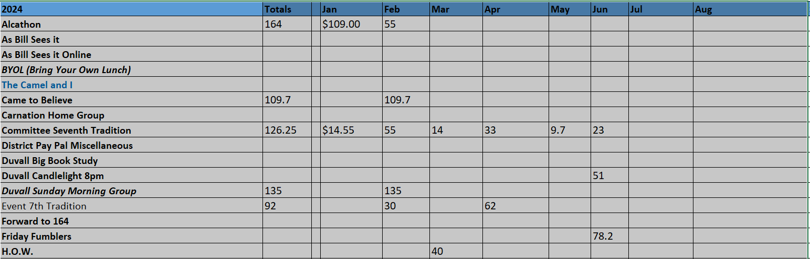
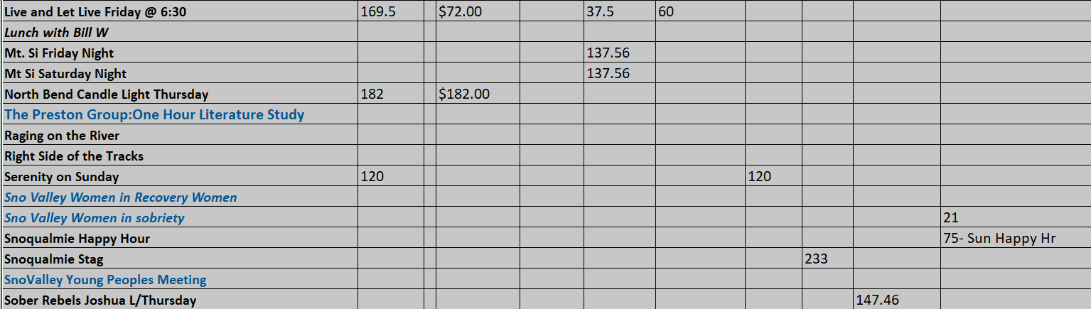
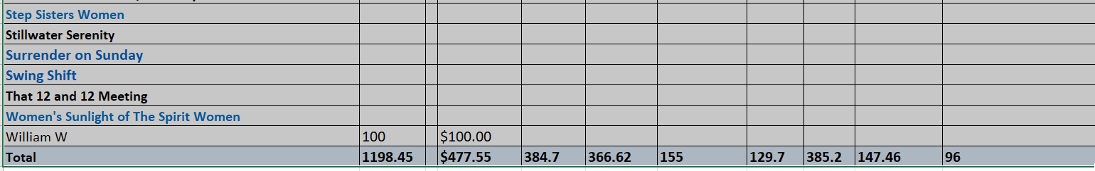
As for web activity, most of the major changes happened in June. For the month of July we had several upgrades to our Web Publishing software (WordPress, currently on version 6.6.1) and started disseminating the information about eastside pre-assembly which our District is hosting this coming Saturday in Duvall.

