District 36 Treasurer’s Report July 2024
https://www.paypal.me/AADistrict36:
https://www.paypal.com/paypalme/AADistrict36
Month to Month Balance
- June 2024 $3,119.84
- July 2024 $3,194.07

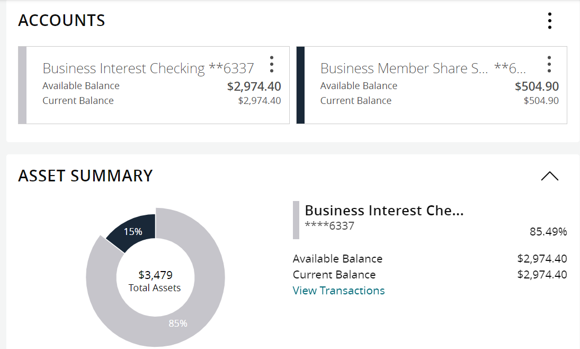

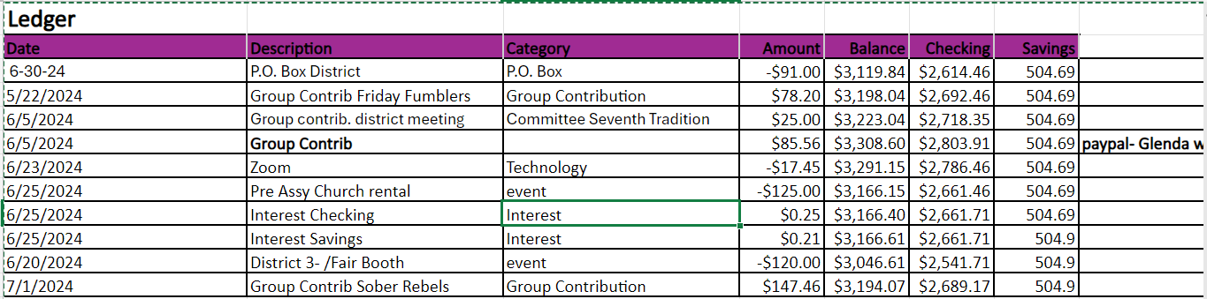
Group Contributions
2024 | Totals |  | Jan | Feb | Mar | Apr | May | Jun | Jul
Alcathon | 164 |  | $109.00 | 55
As Bill Sees it
As Bill Sees it Online
BYOL (Bring Your Own Lunch)
The Camel and I
Came to Believe | 109.7 |  |  | 109.7
Carnation Home Group
Committee Seventh Tradition | 126.25 |  | $14.55 | 55 | 14 | 33 | 9.70 | 23
District Pay Pal Miscellaneous
Duvall Big Book Study
Duvall Candlelight 8pm |  |  |  |  |  |  |  | 51
Duvall Sunday Morning Group | 135 |  |  | 135
MayEvent 7th Tradition | 92 |  |  | 30 |  | 62
Forward to 164
Friday Fumblers |  |  |  |  |  |  |  | 78.2
H.O.W. |  |  |  |  | 40
Live and Let Live Friday @ 6:30 | 169.5 |  | $72.00 |  | 37.5 | 60
Lunch with Bill W
Mt. Si Friday Night |  |  |  |  | 137.56
Mt Si Saturday Night |  |  |  |  | 137.56
North Bend Candle Light Thursday | 182 |  | $182.00
The Preston Group:One Hour Literature Study
Raging on the River
Right Side of the Tracks
Serenity on Sunday | 120 |  |  |  |  |  | 120
Sno Valley Women in Recovery Women
Snoqualmie Happy Hour
Snoqualmie Stag |  |  |  |  |  |  |  | 233
SnoValley Young Peoples Meeting
Sober Rebels Joshua L/Thursday |  |  |  |  |  |  |  |  | 147.46
Step Sisters Women
Stillwater Serenity
Surrender on Sunday
Swing Shift
That 12 and 12 Meeting
Women's Sunlight of The Spirit Women
William W | 100 |  | $100.00
Total | 1198.45 |  | $477.55 | 384.7 | 366.62 | 155 | 129.70 | 385.2 | 147.46

