District 36 Business Meeting Tuesday, July 2nd 2024. Minutes & Reports
● Roll call
- Online- Rob, Lisa, Jeff, Eric, Jerry, Natalie
- Onsite – Paul, Mike L, Patrick, Kent, Glenda, Tami
● June Anniversaries – Tami had 21 years last month.
● Introduction of any new General Services Representatives (GSRs) in attendance – Eric – Snoq Fri night
Committee Chair Reports
- Accessibility - OPEN
- Archives - OPEN
- Cooperation with the Professional Community / Public Information (CPC/PI) - David B – no report
- Corrections - Natalie C – see report below .
- Events - Kathleen M – we had our 4th Hike – more of a walk & breakfast.
  - Next one will be Aug breakfast at Hope Hall 8-9, then walk on trial after
- Grapevine/Literature - Linda Z – ordered new big books, things going well.
- Gratitude Dinner - Brian – Linda, and Gerry are co-chair. Nov 2nd @Mt. Si Community Center
- Intergroup Representative - Kent C –
  - July 27th 11-4 Beaver Lake Picnic. You can get tickets until July 24th. @ ESIG website or call and buy over phone.
  - Live @Pinelake this Sat 6- 8-24
- Third Legacy - OPEN
- Treatment/Bridge the Gap - Kewn – Details below
- Web and Digital - Mario – out of town
- Young People in A.A. - Heather L – great and informative Safety in meeting event.
  - Also a new meeting at Mt. Si High School for age 13-21 closed to others. Tuesdays 3-4pm
● Pause for the Seventh Tradition ○ “Every A.A. group ought to be fully self-supporting, declining outside contributions” – New QR code on Website.

Officer Reports
○ Registrar - Tami B – Updated Friday night GSRs
○ Treasurer - Glenda R – Report Below – motion to approve – all approved.
○ Secretary - Kellie – get better Kellie
○ Alternate District Committee Member (Alt DCM) - Mike L – attend safety in AA Report Below
○ District Committee Member (DCM) - Paul C- Pre assy location, Report Below

Old Business- Location for Eastside Districts pre-assembly – agreed on Holy Innocent in Duvall. Aug 17th 10-2pm
New Business – Steve from District 3 Pi committee District 3 is asking for donations to support the Evergreen State Fair booth the budget for this is $2800 they're looking for each district to support with $120.00 donation plus they need volunteers if you decide to be a volunteer there will be free parking and free admission to the fair for the whole day in total there are 64 volunteers currently there are 7 open if you are interested in volunteering please call Cindy S at 509-552-7227 the date of the fair is August 22nd through September 2nd the shifts will be as follows the volunteers will be spread out through a 12 hour throughout the day at the fair the 1st one is from 10-2:00, 2-4:00 and then last group is from 6:00 to PM to close. I if the shift you're interested in is not available you could also get on a backup list we had a motion to approve to send $120.00 to support the booth at the Evergreen State Fair
● Announcements – Gail & Eddie will have a fire meeting on Friday nights starting June 7th – 30th of Aug @ 7pm
● Reminder for next District 36 Business Meeting ○ Tuesday, July 2nd, 2024, ○ Link to Zoom meeting

July 2024 - Alt DCM Report – District 36
- Coordinate August Pre-Assembly for Eastside Districts (33, 34, 35, 36, 38, and 39). Saturday, August 17 from 10am to 2pm.
- Got reservation for Holy Innocents Church in Duvall o Flyer and info at https://snovalleyaa.org/eastside-districts-pre-assembly-will-be-on-saturday-august-17th-at-holy-innocents-church-in-duvall/
- Still need 8 to 10 volunteers for setup, help run Zoom, and tear down on day of event · Upcoming Area 72 events: https://area72aa.org/events/ o July 5 and 6, Area 72 Business Quarterly in Lacey. https://area72aa.org/event/july-2024-area-72-business-quarterly o July 20, 10am, Delegate Report Back, Everett. https://area72aa.org/event/2024-everett-delegate-report-back/
- The district print schedule is available on our website.
- Lists meetings in the valley
- Web addresses for Eastside Intergroup, Western Washington Area 72, and GSO o https://snovalleyaa.org/wp-content/uploads/2024/02/AA-schedule1_D36_20240206.pdf

July 2024 DCM Report

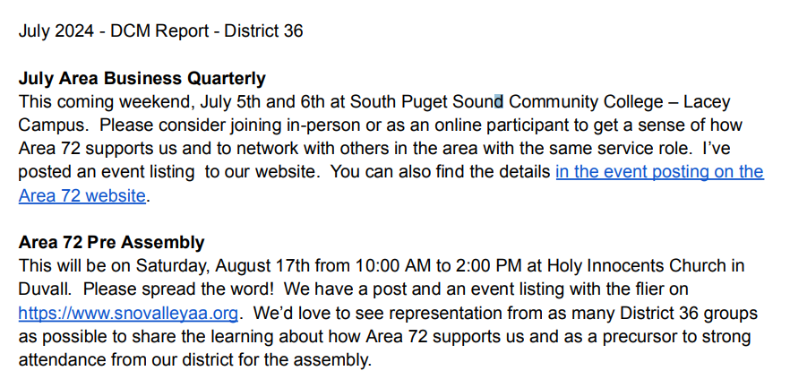
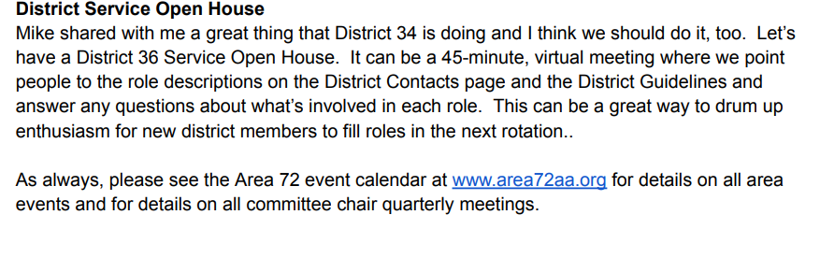
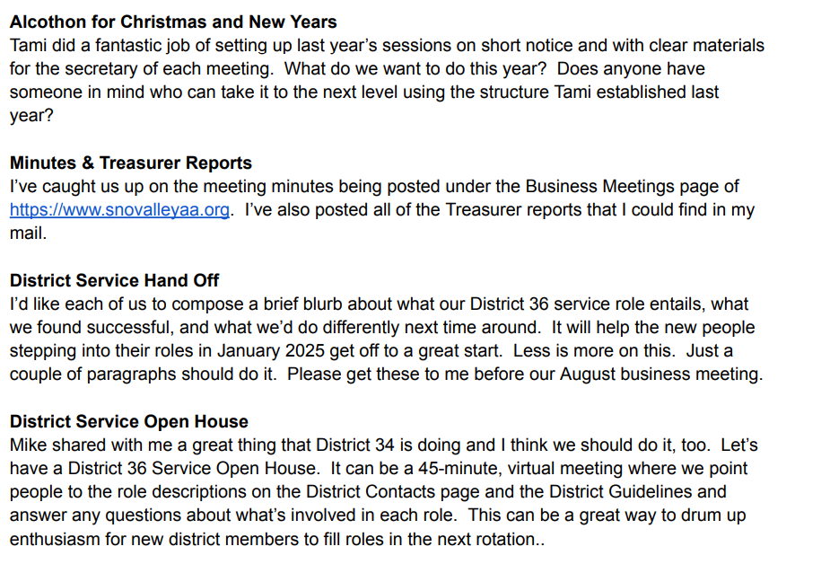

Heather L Young Person in AA Chair

- The youth meeting that was started a few months back - Tuesday 3PM at Lifepointe Church has been disbanded due to low attendance (only one person has shown up to each of the meetings)
- There is a new meeting that has started for young women which will be on Sunday's at Lifepointe Church from 3-4PM - the meetings will begin this Sunday - July 7th.
- ICYPAA (International Conference for Young People in AA) is happening in Austin - July 4-7. I will not be able to attend but I am looking forward to hearing how this years convention goes.

- The WSCYPAA (Washington State Conference for Young People In AA) is being held July 26-28 in Tacoma. Please send link to anyone interested in registering, https://wscypaa7.squarespace.com/
- I will be attending myself along with other youth from our district.
- I previously sent out an email from Seth G discussing the video project for youth in AA. Please review with committee.
- That is all I have for now. Please know that I am always available day or night to help a youth (or anyone for that matter). My number is 425.647.4831. Please feel free to give it to any youth at anytime who needs someone to support them,

Respectfully Submitted, Heather L Young Person in AA Chair

District 36 Treasurer’s Report July 2024

https://www.paypal.me/AADistrict36:
https://www.paypal.com/paypalme/AADistrict36
Month to Month Balance
- June 2024 $3,119.84
- July 2024 $3,194.07

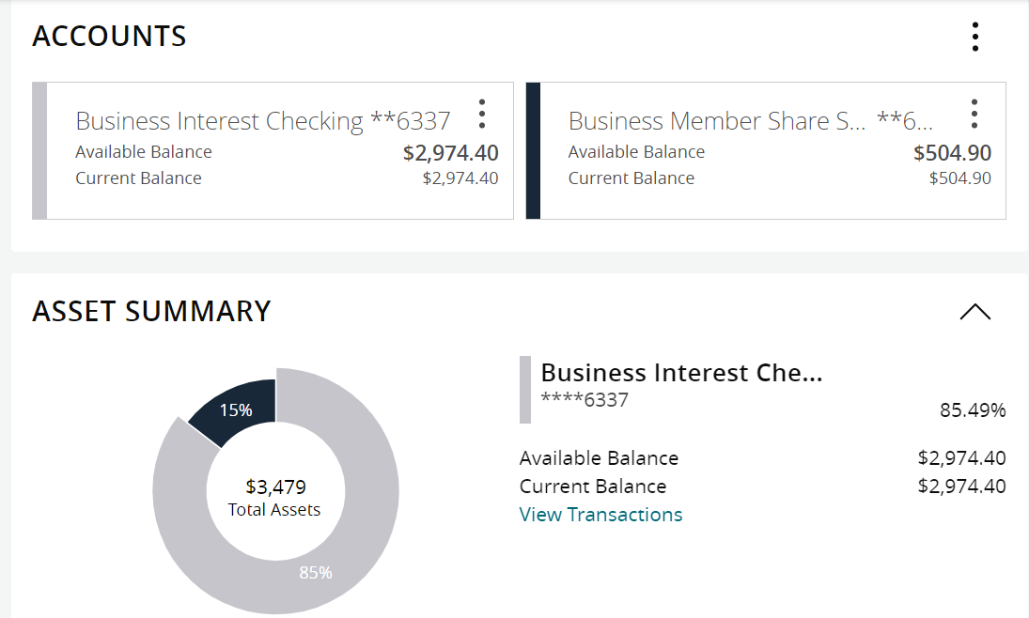

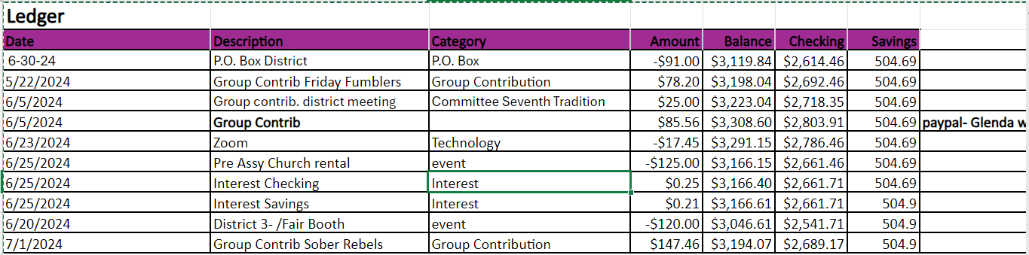
Group Contributions
2024 | Totals |  | Jan | Feb | Mar | Apr | May | Jun | Jul
Alcathon | 164 |  | $109.00 | 55
As Bill Sees it
As Bill Sees it Online
BYOL (Bring Your Own Lunch)
The Camel and I
Came to Believe | 109.7 |  |  | 109.7
Carnation Home Group
Committee Seventh Tradition | 126.25 |  | $14.55 | 55 | 14 | 33 | 9.70 | 23
District Pay Pal Miscellaneous
Duvall Big Book Study
Duvall Candlelight 8pm |  |  |  |  |  |  |  | 51
Duvall Sunday Morning Group | 135 |  |  | 135
MayEvent 7th Tradition | 92 |  |  | 30 |  | 62
Forward to 164
Friday Fumblers |  |  |  |  |  |  |  | 78.2
H.O.W. |  |  |  |  | 40
Live and Let Live Friday @ 6:30 | 169.5 |  | $72.00 |  | 37.5 | 60
Lunch with Bill W
Mt. Si Friday Night |  |  |  |  | 137.56
Mt Si Saturday Night |  |  |  |  | 137.56
North Bend Candle Light Thursday | 182 |  | $182.00
The Preston Group:One Hour Literature Study
Raging on the River
Right Side of the Tracks
Serenity on Sunday | 120 |  |  |  |  |  | 120
Sno Valley Women in Recovery Women
Snoqualmie Happy Hour
Snoqualmie Stag |  |  |  |  |  |  |  | 233
SnoValley Young Peoples Meeting
Sober Rebels Joshua L/Thursday |  |  |  |  |  |  |  |  | 147.46
Step Sisters Women
Stillwater Serenity
Surrender on Sunday
Swing Shift
That 12 and 12 Meeting
Women's Sunlight of The Spirit Women
William W | 100 |  | $100.00
Total | 1198.45 |  | $477.55 | 384.7 | 366.62 | 155 | 129.70 | 385.2 | 147.46

